Computational predictions of stable phase for antiperovskite Na3OCl via rotation of ONa6 octahedra
Tan-Lien Pham, Abdus Samad, Hye Jung Kim and Young-Han Shin∗

Department of Physics, University of Ulsan, Ulsan 44610, Republic of Korea

∗E-mail : hoponpop@ulsan.ac.kr
Antiperovskite Na₃OCl has been considered as a candidate material for solid elec- trolyte. Hippler et al. reported Na₃OCl in cubic phase Pm3¯m [1] but Zinenko et al. showed unstable phonon modes at the R and M points for cubic Na₃OCl [2]. In this work, we study the structural stability of Na₃OCl in terms of energy landscapes and phonon spectra with the rotation of ONa₆ octahedra. We prove that the cubic Na₃OCl can be energetically stabilized through octahedral tilts among 15 possible tilted systems consistent with Howard and Stokes’ group-theoretical analysis of octahedral tilting in perovskites [3]. We find that all 14 tilted structures of Na₃OCl are more stable than the cubic Pm3¯m by 11-16 meV per five-atom unit cell. The tilt angles along the pseudocu- bic [100], [010], and [001] directions vary in the range of 2.6–9.3◦. While the Pnma and P2₁/m structures of Na₃OCl are found as the two most stable ones, only the P2₁/m phase has stable phonon vibrations with a direct band gap of 3.38 eV at the Γ point.

References
- K. Hippler, S. Sitta, P. Vogt, and H. Sabrowsky, Acta Crystallographica Section C
46, 736 (1990).

- V. I. Zinenko and N. G. Zamkova, Ferroelectrics 265, 23 (2002).

- C. J. Howard and H. T. Stokes, Acta Crystallographica Section B 54, 782 (1998).

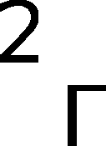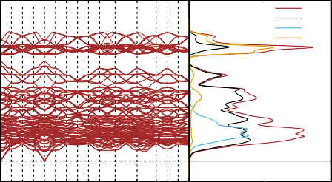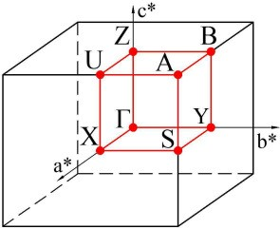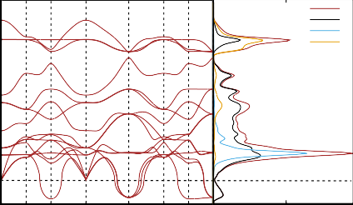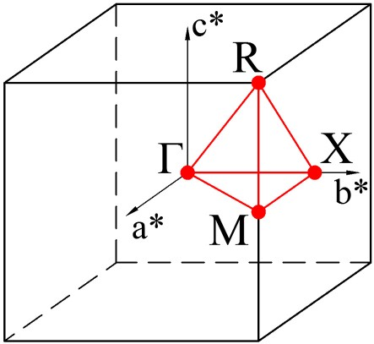14
14
12
10
8
6
4
(c)
(d)
Total Na Cl O
0
−
X S Y Z U A B Z Y B U X S A Density of States
(a)
(b) Total
Na Cl O
X M
R X M R Density of States
12
10
Frequency (THz)
Frequency (THz)
8
6
4
2
0
2

Figure 1: (a) Phonon band structure and (b) density of states of the cubic Pm3¯m phase. The soft modes at M and R points in the phonon band structure indicate that the cubic Pm3¯m phase is dynamically unstable. (c) Phonon dispersion curves and (d) densities of states of monoclinic P2₁/m. The phonon dispersion curves and the total density of states show no negative modes, which proves the monoclinic P2₁/m is dynamically stable.

